Program Testing

Foundation Programming

Arsalan Sadeghpour



Test Plan

|  |  |  |  |
| --- | --- | --- | --- |
| Test | Input Data | Output Expected | Comment |
| The Menu – 1 | Integer 1 | Prompt To Enter 10 Teams | Simple Validation |
| The Menu – 2 | Integer 5 | Program Terminates | Simple Validation |
| The Menu – 3 | Integer 2 | Error Message | Cannot Display League Without Initialization |
| The Menu – 4 | Integer 3 | Error Message | Cannot Add Match Scores Without Initialization |
| The Menu – 5 | Integer 4 | Error Message | Cannot Display Team History Without Initialization |
| The Menu – 6 | Integer 6 | Error Message | Invalid Boundary |
| The Menu – 7 | Special Characters | Error Message | Data Type |
| The Menu – 8 | Characters | Error Message | Data Type, Random Input |
| The Menu – 9 | <Blank> | Error Message | Data Type |
| The Menu - 10 | Decimal 2.5 | Error Message | Data Type |
| Create League -1 | Characters a/A | Enter Next Team | Simple Validation |
| Create League – 2 | Blank Spaces | Enter Next Team | Simple Validation |
| Create League – 3 | Character 10 | Enter Next Team | Valid Boundary |
| Create League – 4 | Characters 15 | Enter Next Team | Boundary |
| Create League – 5 | Characters 30 | Error Message | Invalid Boundary |
| Create League – 5 | Special Characters | Error Message | Data Type |
| Create League - 6 | <Blank>, | Error Message | Data Type, |
| Display League Table – 1 | N/A | League Table should Display with Correct Headings, Correct Team names and values initialized to 0 | Simple Validation |
| Add Match – 1 | Characters – Home & Away League Teams | Enter Score | Simple Validation |
| Add Match – 2 | Integers – Enter Score | The Menu | Simple Validation |
| Add Match - 3 | Integers – Enter Score 999-999 | Error Message | Invalid Boundary |
| Add Match - 4 | Non Existent Teams | Error Message | Random Input |
| Add Match - 5 | Special Characters | Error Message | Data Type |
| Add Match - 6 | <Blank> | Error Message | Data Type |
| Add Match - 7 | Decimals – Enter Score | Error Message | Data Type |
| Add Match - 8 | Integers – Home & Away Teams | Error Message | Data Type |
| Display League Table 2 | N/A | League Table should Display with Correct Headings, Correct Team names and corresponding values | Simple Validation |
| Team History - 1 | Team in League | Display History | Simple Validation |
| Team History - 2 | Non Existent Team | Error Message | Random Input |
| Team History - 3 | Special Characters | Error Message | Data Type |
| Team History - 4 | Integers - 2 | Error Message | Data Type |
| Team History - 5 | Decimal 2.5 | Error Message | Data Type |
| Team History - 6 | <Blank> | Error Message | Data Type |
| Team History - 7 | Case A/a | Error Message | Data Type |

Test Log – 24/1/13

|  |  |  |
| --- | --- | --- |
| Test | Result | Comment |
| The Menu – 1 | Enter 10 Teams Correct |  |
| The Menu – 2 | Program Terminates Correct |  |
| The Menu – 3 | No Error Message Displayed, Random Characters Displayed | Provide an error message and return to the menu screen |
| The Menu – 4 | Allows Input of Goals but all data input is non existent | Provide an error message and return to the menu screen |
| The Menu – 5 | No error message but Program Crashes | Provide an error message and return to the menu screen |
| The Menu – 6 | Program redisplays Menu | Add Validation |
| The Menu – 7 | Program Crashes | Add Validation |
| The Menu – 8 | Program Crashes | Add Validation |
| The Menu – 9 | Program Crashes | Add Validation |
| The Menu - 10 | Program Crashes | Add Validation |
| Create League -1 | Program allows entry of uppercase & lowercase letters |  |
| Create League – 2 | Program Crashes | Add Validation |
| Create League – 3 | Program Allows values greater than the array |  |
| Create League – 4 | Program Accepts Boundary of Array | Add Validation |
| Create League – 5 | Program Allows values greater than the array |  |
| Create League - 6 | Program Crashes | Add Validation |
| Display League Table - 1 | Table displays with all values to 0 after creation of the league. |  |
| Add Match – 1 | Program accepts teams |  |
| Add Match – 2 | Program accepts scores |  |
| Add Match - 3 | Program Accepts Random Scores |  |
| Add Match - 4 | Program accepts non existent teams. | Add Validation text to user |
| Add Match - 5 | Program Error message says team does not exist |  |
| Add Match - 6 | Program Error message says team does not exist |  |
| Add Match - 7 | Program starts add match function again |  |
| Add Match - 8 | Program Error message says team does not exist |  |
| Display League Table - 2 | League Table displays all values correctly after valid add match entries | The League Table is not sorted, add sorting function to program. |
| Team History - 1 | Program displays team game history of teams in league |  |
| Team History - 2 | Program displays history but incorrect values | Add Validation to ensure team entered is existent in League |
| Team History - 3 | Program displays history but incorrect values | Add Validation to ensure team entered is existent in League |
| Team History - 4 | Program displays history but incorrect values | Add Validation to ensure team entered is existent in League |
| Team History - 5 | Program displays history but incorrect values | Add Validation to ensure team entered is existent in League |
| Team History - 6 | Program displays history but incorrect values | Add Validation to ensure team entered is existent in League |
| Team History - 7 | Program displays history but incorrect values | Add Validation to ensure team entered is existent in League |

# Testing The Menu

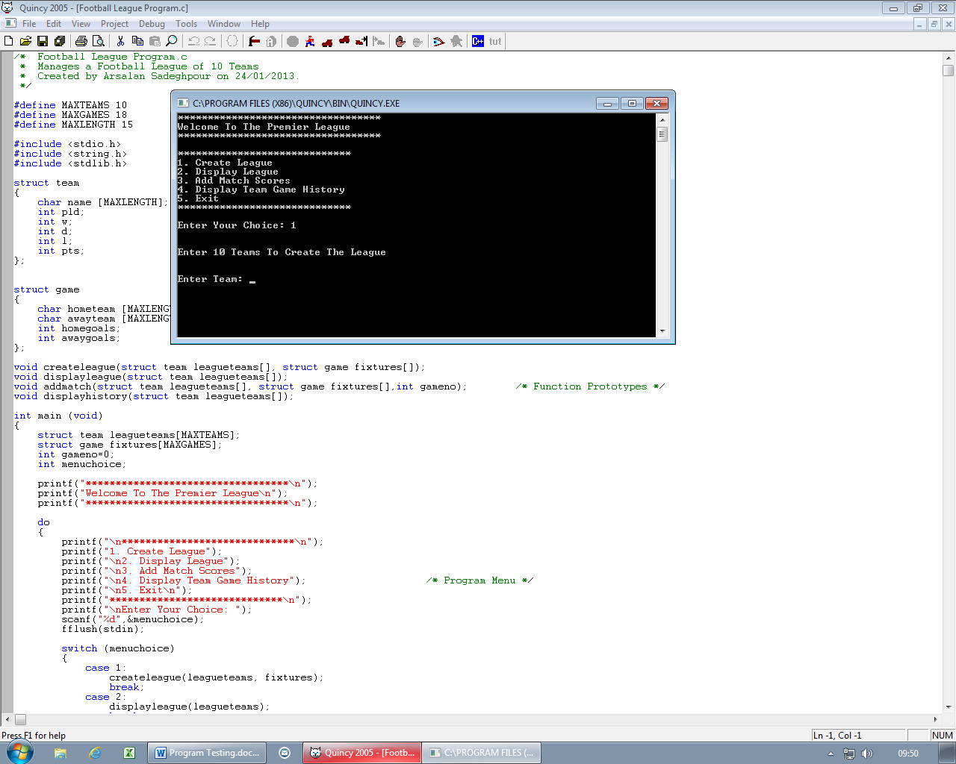

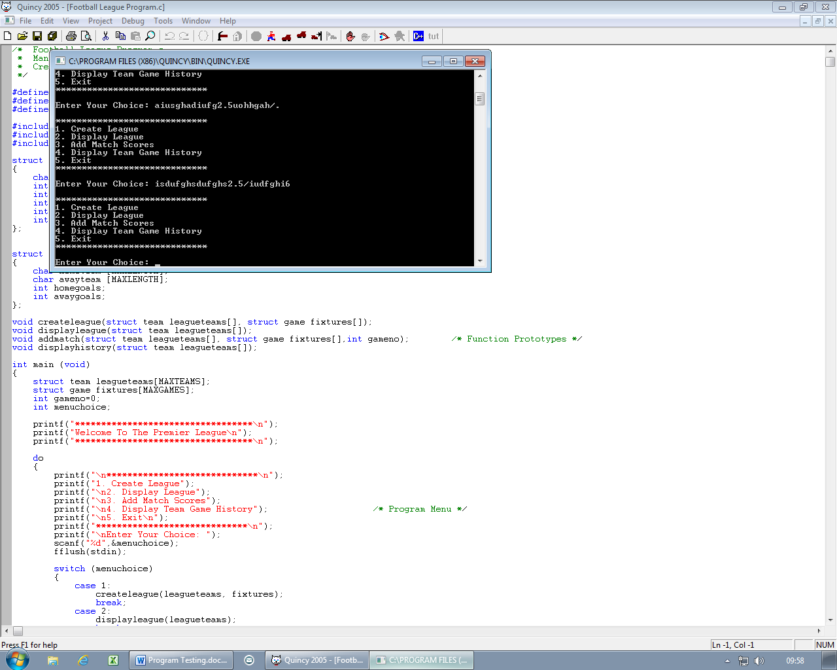

# Testing Create League

# 

# Testing Display League

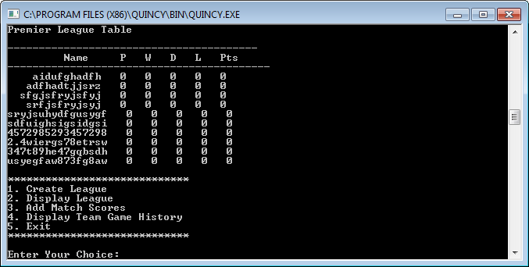

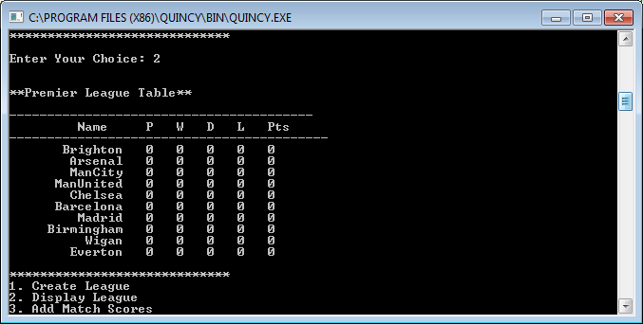

# Testing Add Match

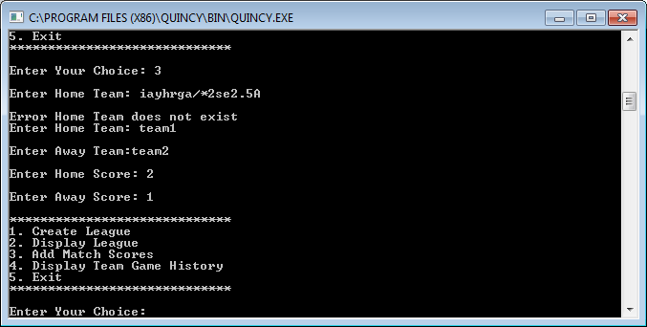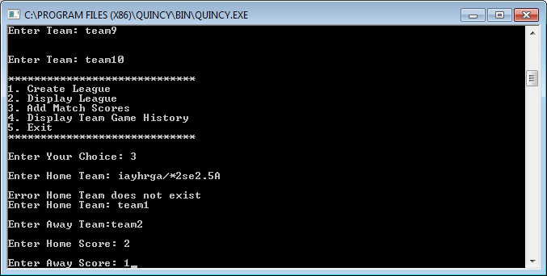

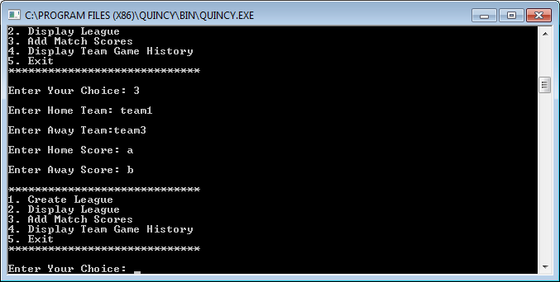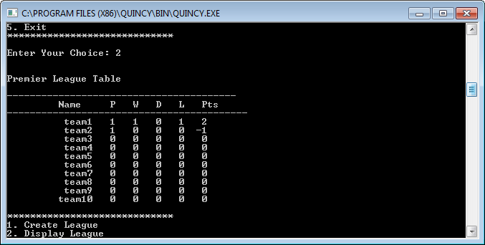

# Testing Display Team Game History

